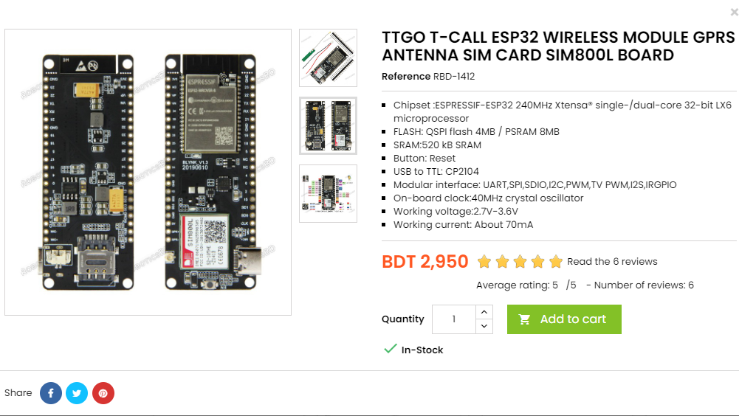

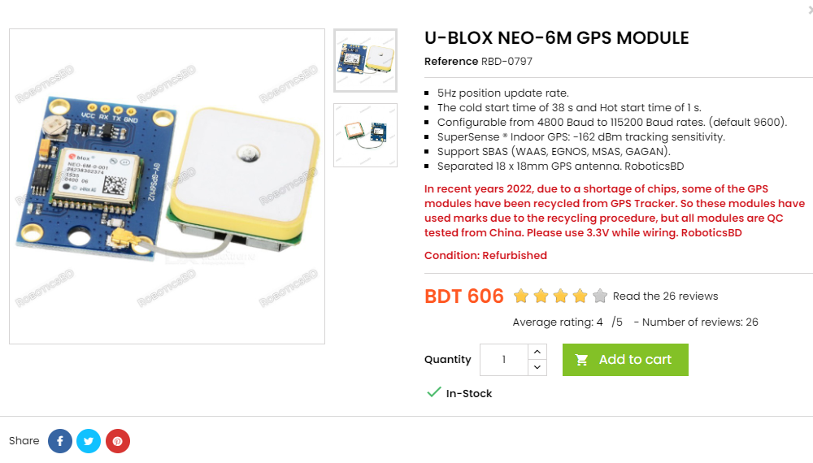

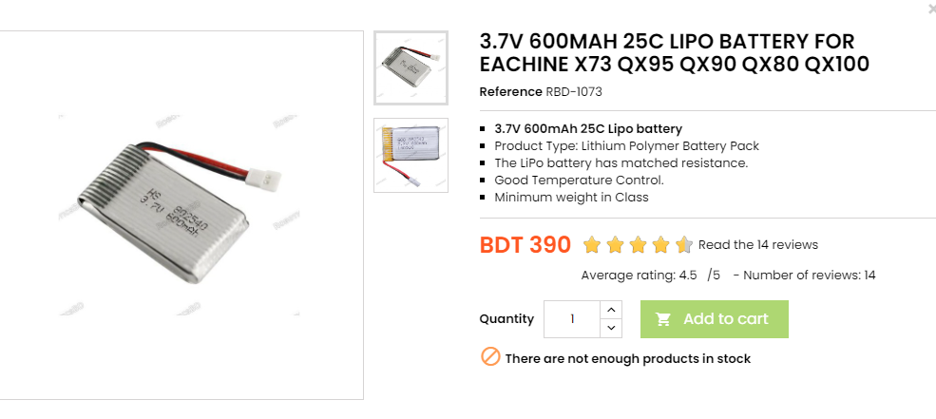

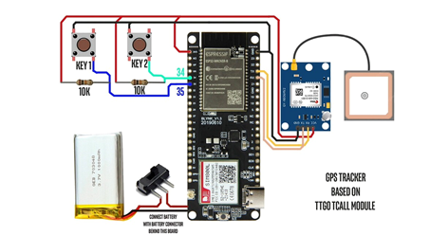

TTGO T-Call ESP32 SIM800L : 2950

U-BLOX NEO 6M GPS Module: 606

3.7V 600MAH LIPO Battery: 490

Power Adaptor and Distribution Board : 3000

PCB Board : 500

GPS Antenna : 600

GPRS Antenna : 600

Case : 2000

SIM card: 300

Total: 11,046 (Without Experiment Cost)

Experimental Approximate Cost:

BreadBoarads+Vero Boards : 500

Multimeter (Signal Testing purpose): 500

Soldering and Other elements: 500

Jumper wires: 300

USB+ Connectors: 200

Total: 2000